EPM User Guide for JTI Market Operations Team

Logging into EPM

To log into the EPM tool, just open a browser and access the URL http://mr2ds0024/PWA/default.aspx

Setting up of initial EPM project plan

The required tasks for the setup of the EPM tool are as follows:-

- Create a new project plan in Microsoft Project 2007 with the initial set of tasks and basic project information

- Publish project plan on EPM

- Review team hierarchy on EPM set up by checking the Timesheet Manager for each of the resources

- Build resource pool by assigning the respective resources in the team to the project plan

P.S: Recurrent tasks need to be defined using Microsoft Project 2007 as it is the only way through which we can define multiple assignee to a single task.

Modify resource pool assigned to the project

- Click on Project Center and select the project for which the resource pool needs to be modified.

- Click on the icon for

- The following screen will be displayed:-

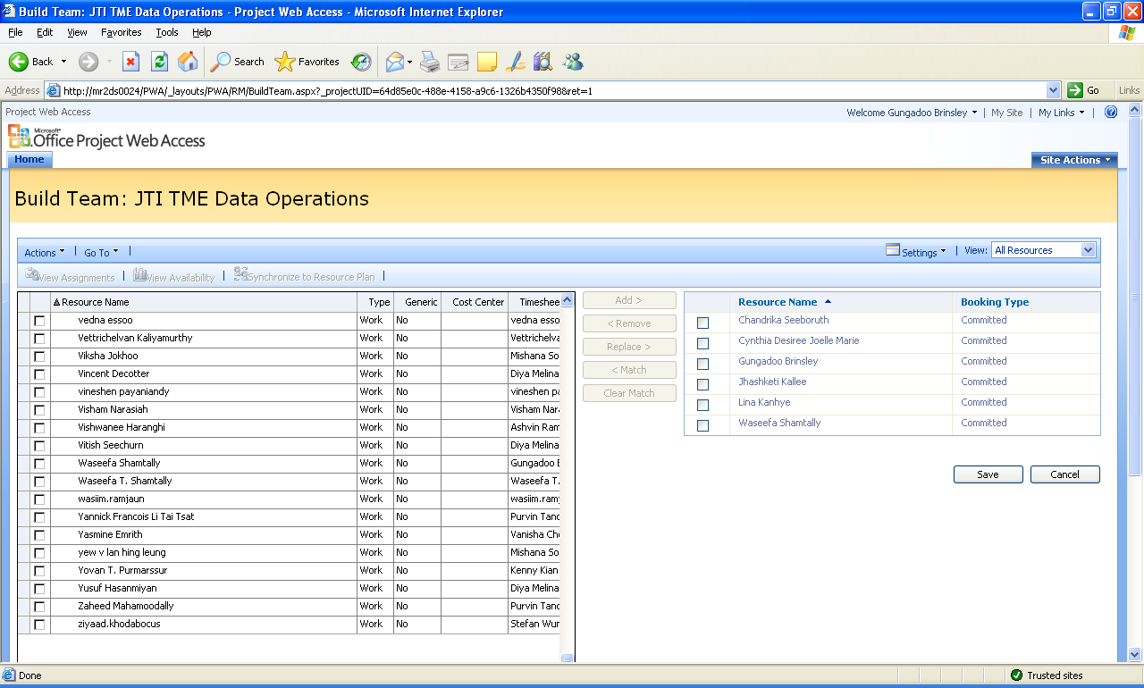

- Select the resource from the left and right list accordingly.

Submission of adhoc tasks

- Log into EPM

- Access My Tasks from the left column

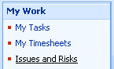

- Your default task assignment will be displayed as follows:-

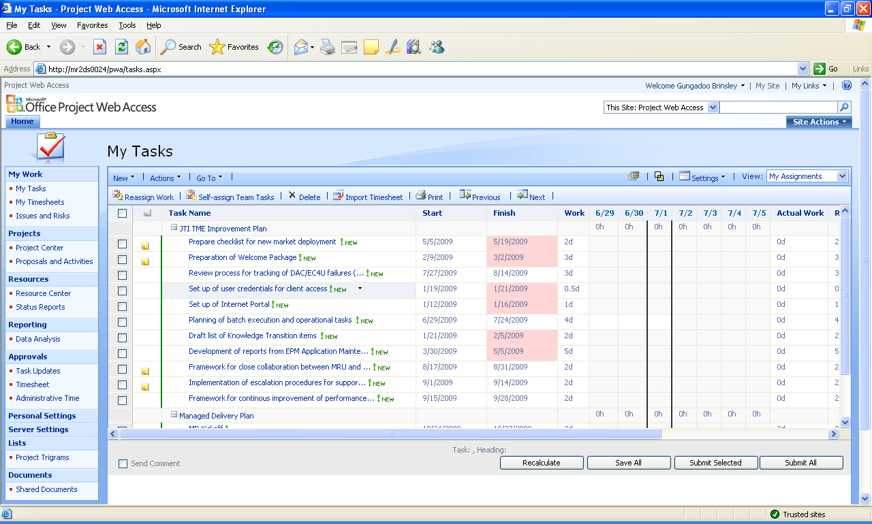

- Click on New -> Task

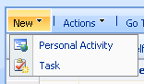

- Enter the details of the new tasks on which you need to track you time.

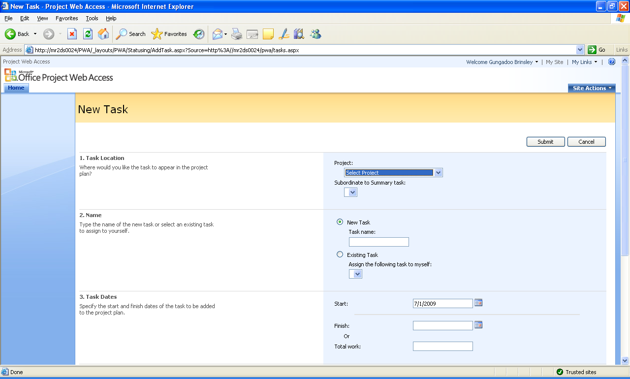

- Select the project to “JTI TME Data Operations”

- Select the Subordinate to Summary Task according to the type of tasks you are tracking:-
  - Adhoc Tasks – any tasks for which no issue tracking or Service requests has been received
  - Batch Execution – Service Requests for batch process execution
  - Data Update & Reload – Service Requests for data reload and update received from the data team
  - DRP tasks – Service Requests and tasks related to DRP execution
  - Adhoc Flat File load – Service Requests for adhoc flat file loads
  - Deployments Tasks – Issues, flat file load and batch process execution related to deployments markets
  - Issues investigation – Service Request describing issues for live market and which has been handled by the market operations team.
  - Administrative tasks – recurrent administrative tasks such as meeting, welfare development, capability development, CMMI, internal team meeting, conference call, etc…

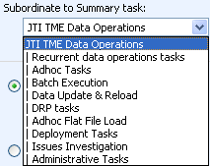

Please note that no tasks should be added under the title “Recurrent data operations tasks” and “Administrative Tasks”. If ever there is a need to add a specific task under these categories, kindly consult the Project Manager.

- Enter the name of the new task according to the following format:
  - SR XXXXXX – Batch request description
  - SR XXXXXX – Adhoc flat file load details
  - Issue XXX – Deployment tasks details
  - A – Details of adhoc tasks executed

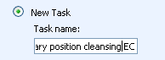

- Enter the details of the tasks estimates in terms of the planned start and end date and the estimated amount of time to work on the issue.

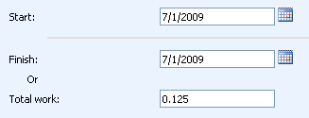

- Check to have the new tasks added to your timesheet and any other comments that you might have regarding this tasks.

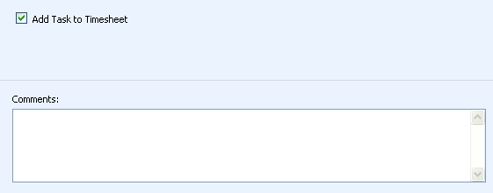

- Click on “Submit” button

Re-assigning tasks to another resource

In case you need to re-assign a task which is currently assigned to you, please perform the following operations:-

- First select the tasks that you want to re-assign in the “My Tasks” screen.

- Then click on the following button.

- The following screen will be displayed. From it, select the resource to which you want to assign the task.

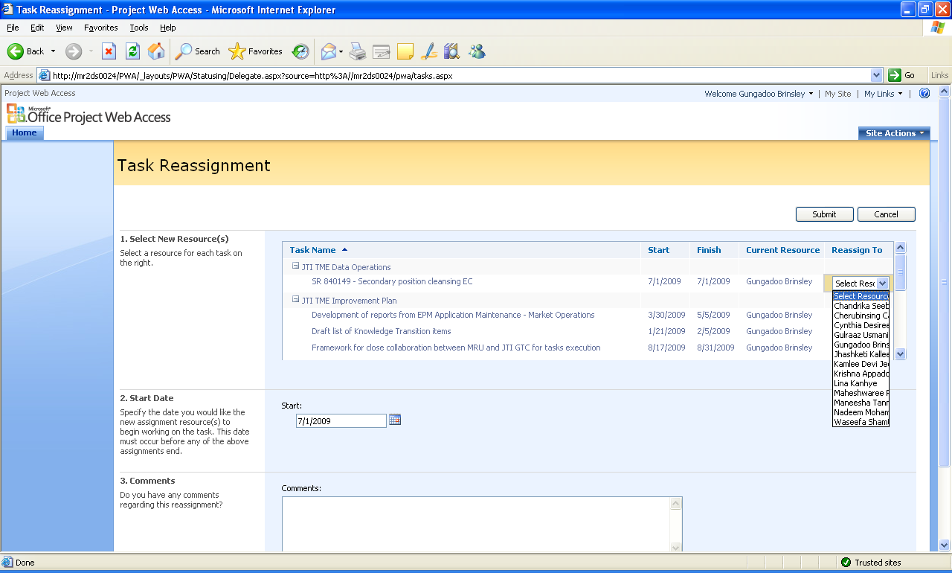

- Then click on the Submit button.

Approving and publishing new tasks in project plan

- Access “Task Updates” under the section Approvals.

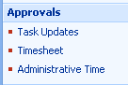

- The following screen will be displayed with the pending tasks that need to be approved and published into the project plan.

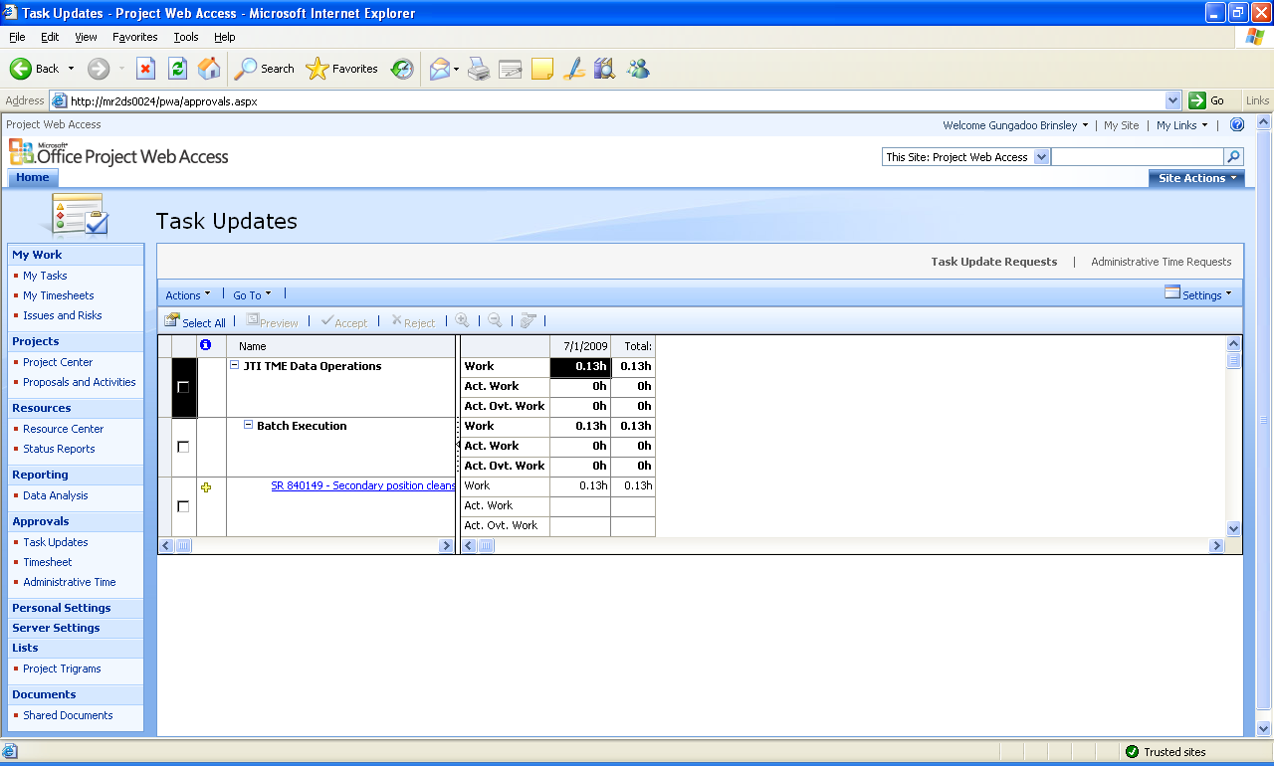

- Select the tasks that need to be approved.

- Click on “Accept” button

- The following screen will be displayed whereby any comments on the tasks being integrated can be inserted.

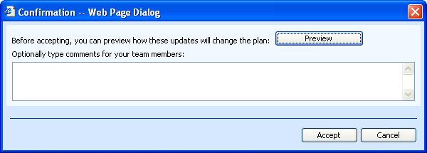

- Click on the Accept button.

- Once all the pending tasks are approved and integrated into the Project Plan, the following screen will be displayed.

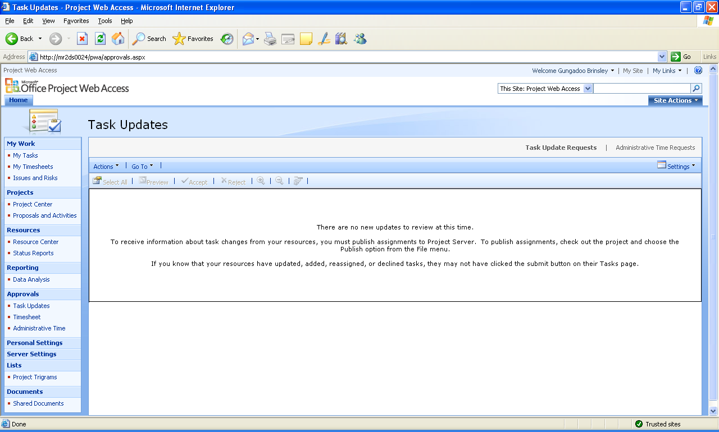

- To verify that the task has been correctly integrated in the project plan, it can be reviewed through the Project Centre.

Planning and recording your administrative time in your timesheet

Administrative time includes the following categories of time:-
- Public Holiday
- Sickness
- Vacations
- Unassigned
- Administrative tasks such as meeting, other non project activities, non project activities

- In “My timesheet”, select click on



- The following screen will be displayed:-

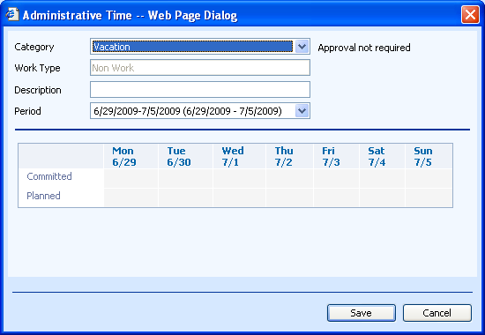

- Select the time of administrative time, enter the description and record the time planned for each administrative task and click on the “Save” button.

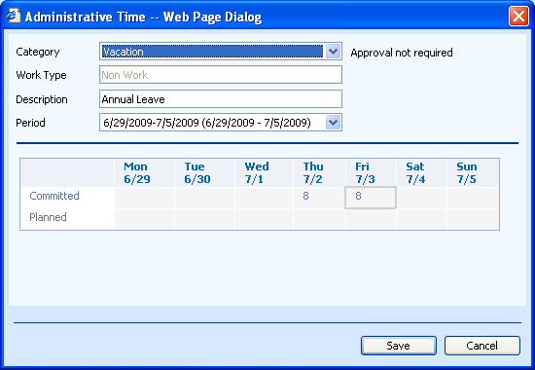

Please note that any administrative time entered will need to be approved by your timesheet manager. As such, the entry status will be in Yellow in your time sheet entry.

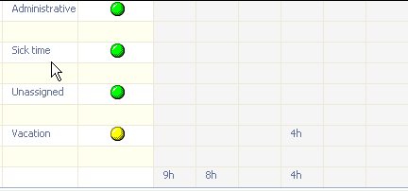

Your timesheet manager will receive a request to approve the pending administrative time-off request.

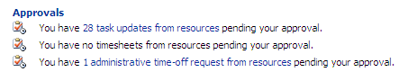

Once it is approved, then the status will turn to “Green”.
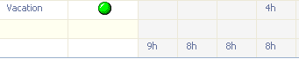

Completing time sheet entry

- To complete your time sheet entry, access the My Timesheet screen from the left column.

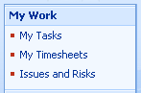

- The following screen will be displayed.

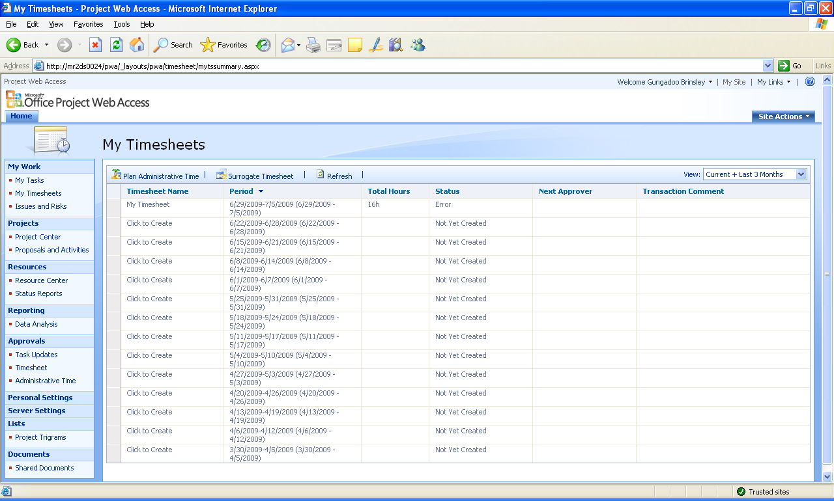

- Open your timesheet entry for the current week by clicking on it.

- The following screen will be displayed:-

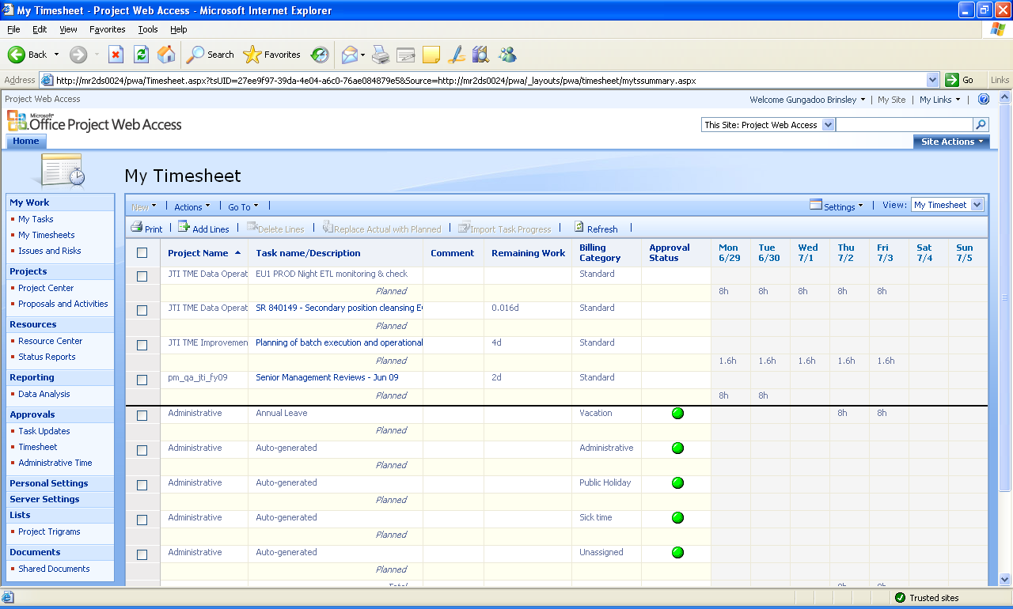

- If the tasks on which you need to enter your time for this week is not present, click on the “Add Lines”

- The following screen will be displayed:-

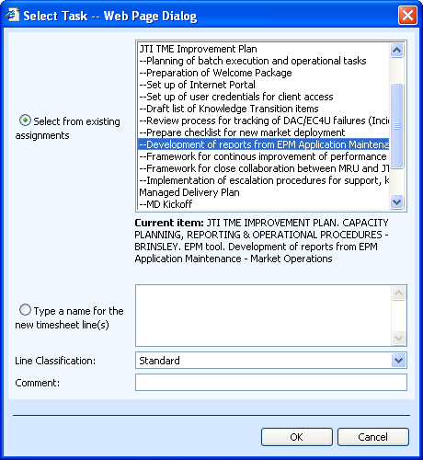

- Select the new tasks either from an existing task or type a new name for the tasks to be added and then click on the “Ok” button.

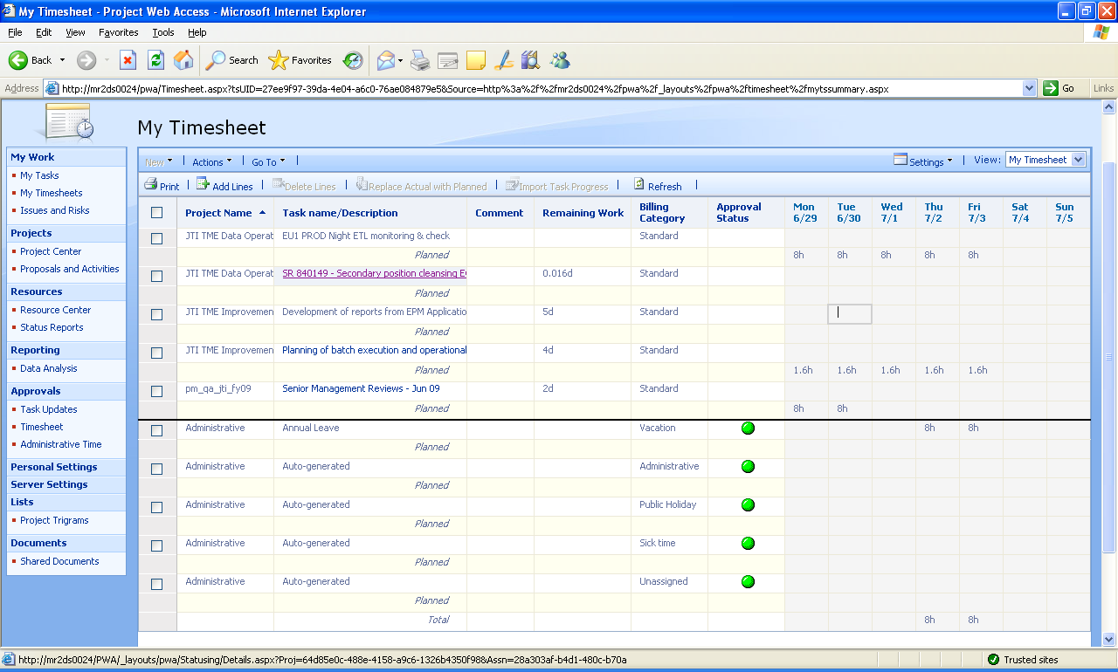

- Enter your time spent in the line next to the tasks as shown in the highlighted example below.

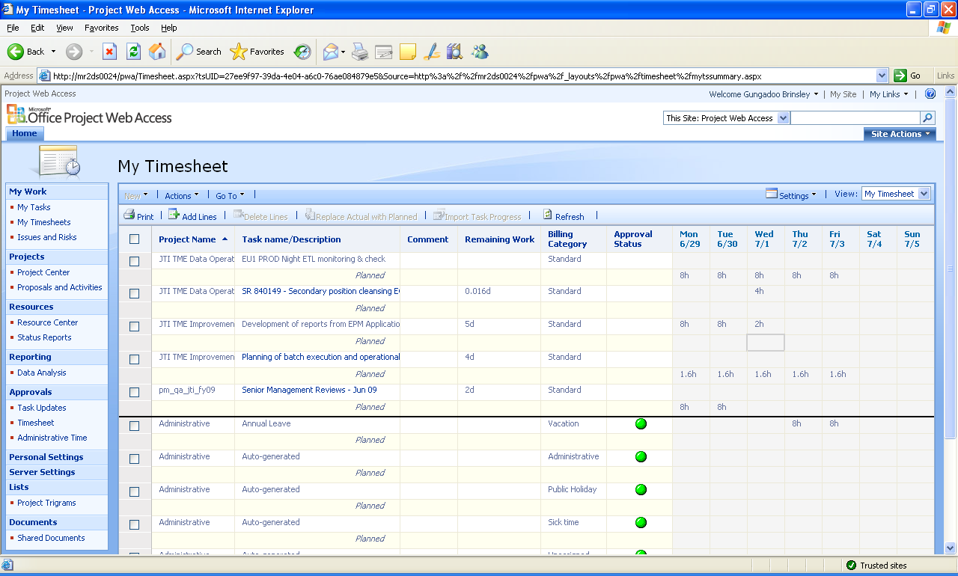

- Once all missing tasks are added and the entries entered for the time spent on each item during the day, you would need to recalculate your time sheet entry.

- Once recalculated, the timesheet can be reviewed by checking the overall time for the week and the time on a daily basis.

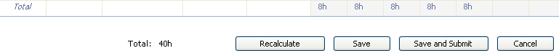

- Proceed to delete the unused lines from the timesheet entry by selecting the redundant lines and clicking on the button

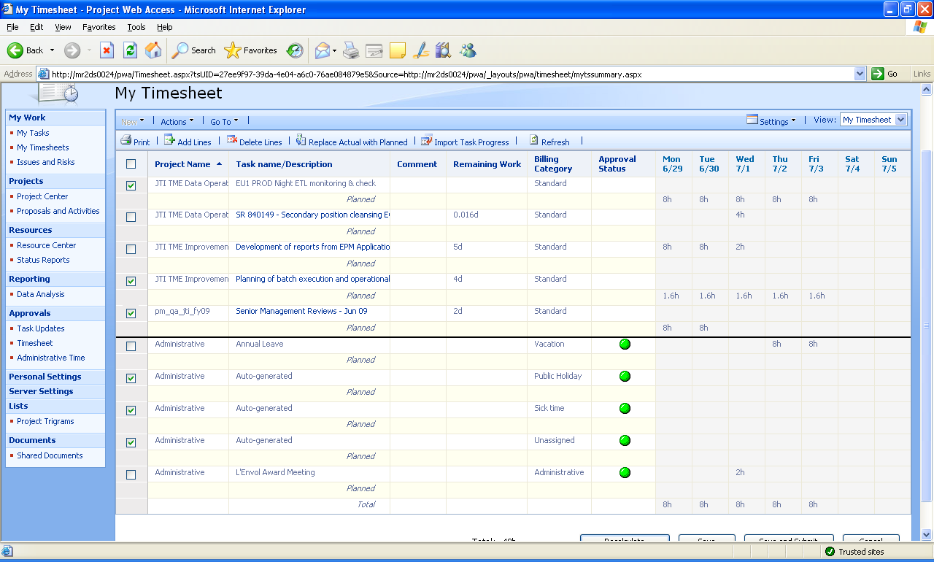

- You will receive a dialog box to confirm whether you wish to proceed with the deletion of these time entries.

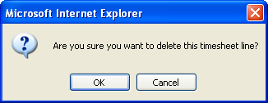

- Click on the “Ok” button. The final time sheet entry would look something like below:

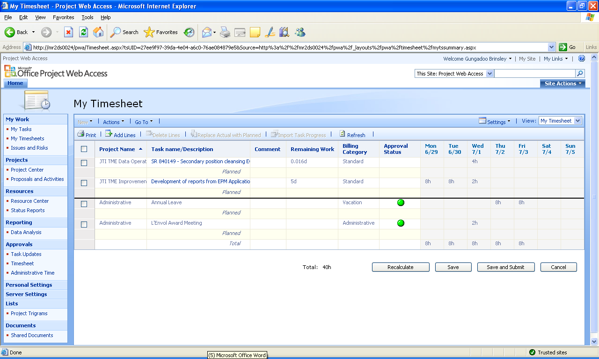

- Once reviewed, click on “Save and Submit” button.

If you have submitted your TimeSheet by error, click on the “Actions” Tab and select “Recall Timesheet” and SAVE again.

Approval of Timesheet by Team Lead (Timesheet Manager)

Once the timesheet has been submitted, it needs to be approved before it is imported in the tasks. As such, the team lead would be required to perform the following operation to approve the timesheet:-

- Click on “Timesheet” in the approvals section.

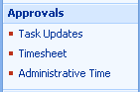

- The following screen will be displayed whereby you would be required to approve the different timesheets pending on you.

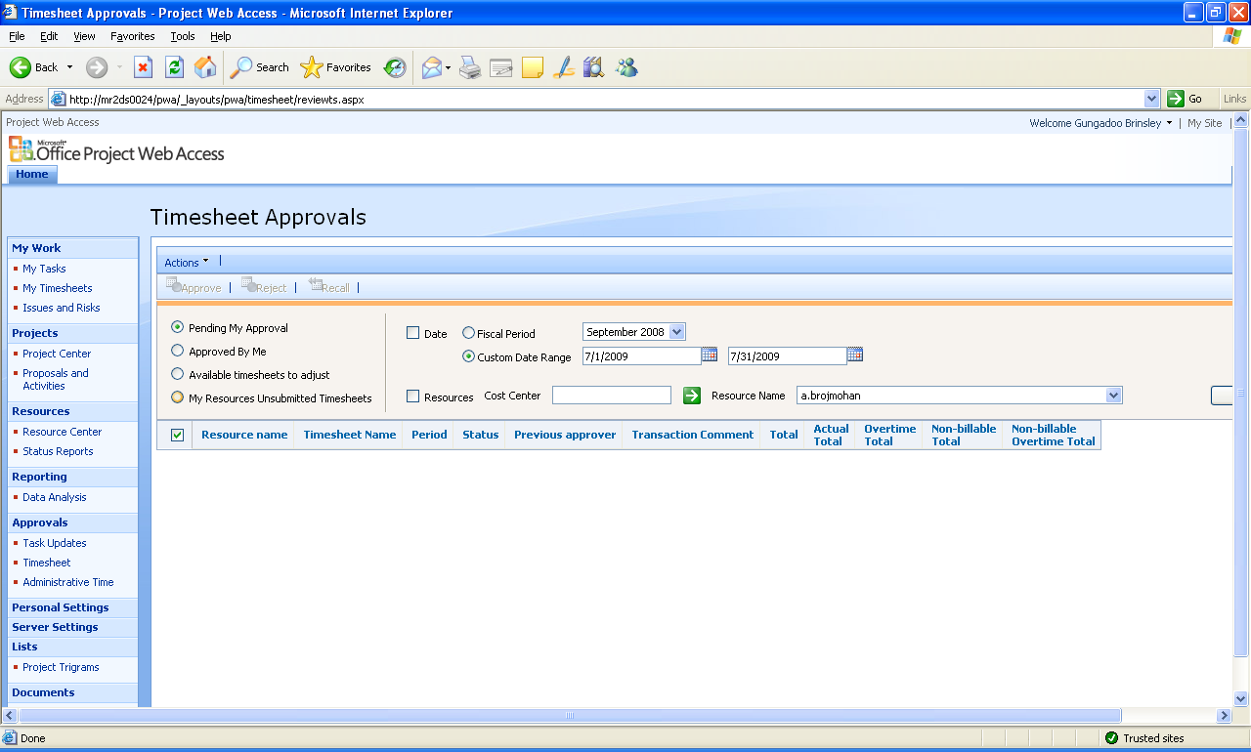

Importing your timesheet into the task sheet

- Go to the My Tasks view

- Click on “Import Timesheet”

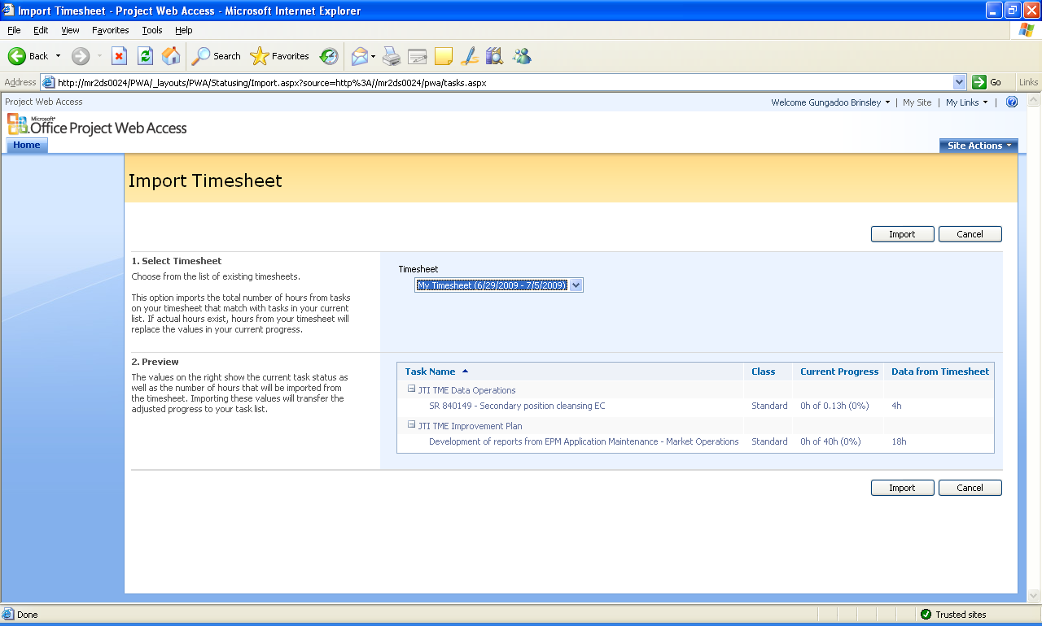

- Select the timesheet to be imported and click the “Import” button.

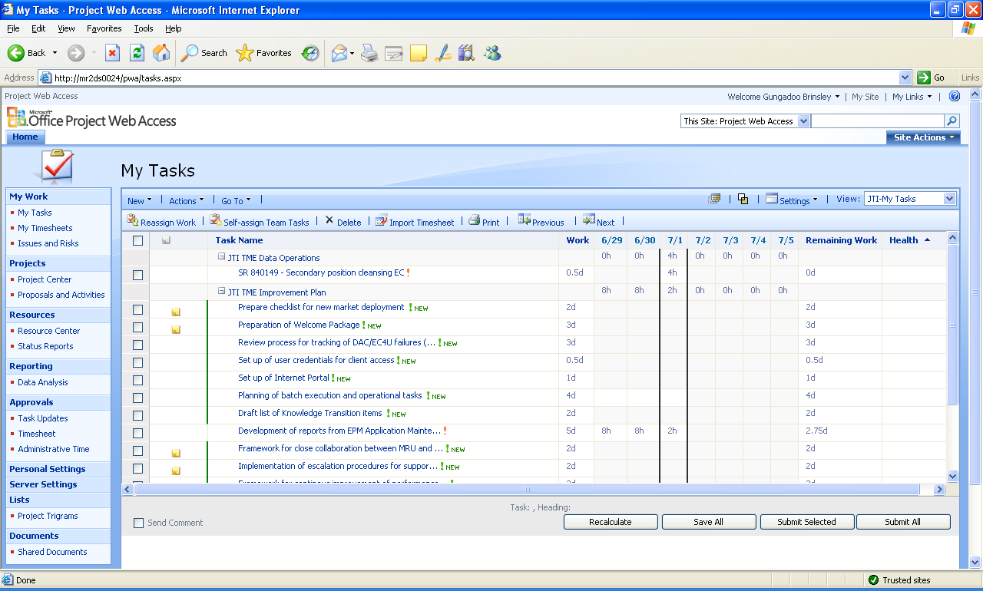

- The My Tasks page will display the imported tasks (“!“ in red + also, in some case, the tasks updated are not marked with a colored Line) e.g.

- Update the remaining work and health state of the tasks according to the following scenario

Scenario 1: The task is completed, the field shows: “0d”
    - Select “Completed” in Health Field (Click somewhere else to validate)

Scenario 2: The task is completed, but the field shows some Values
    - Put 0d in remaining work
    - Select “Completed” in Health Field (Click somewhere else to validate)

Scenario 3: The task is not completed (irrespective of the amount of Remaining Days showed)
    - Update (if necessary) the remaining work according to the estimated amount of time needed to completed the task
    - Select the health either to “On Schedule”, “Late”, “Early”

PLEASE NOTE THAT ACTION 5 SHOULD NEVER BE PERFORMED FOR A RECURRENT TASK (WHICH IS NEVER COMPLETED AND ALWAYS HAVE SOME PENDING WORK WHICH REMAINS TO BE DONE ON IT). THIS INCLUDES ALL ITEMS UNDER “RECURRENT DATA OPERATIONS TASKS” and “ADMINISTRATIVE TASKS”.
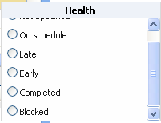

- For market operation tasks, two new custom fields have been added in EPM. You would be required to fill in these fields whenever you are submitted your tasks in EPM. These fields are available in the ‘JTI Data Ops View’.

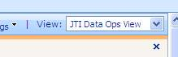

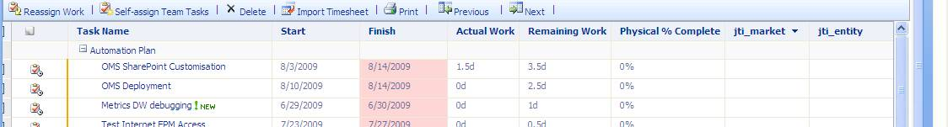

The jti_market field should reference the market for which the task is linked to.
The jti_entity field should reference the flat file entity or the batch process for which the tasks is associated.

- Proceed by selecting the tasks and save all. The following screen will be displayed.

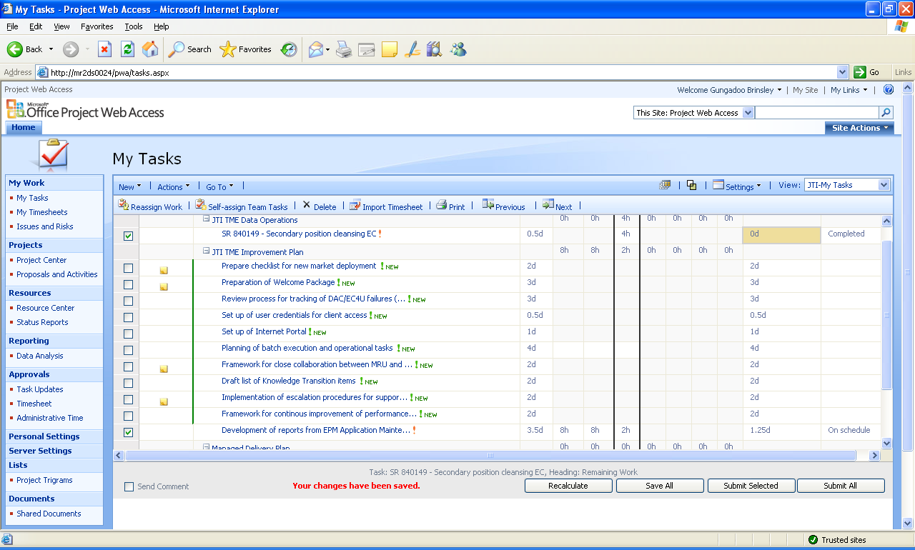

- Once all the changes have been saved the following message will be displayed:-

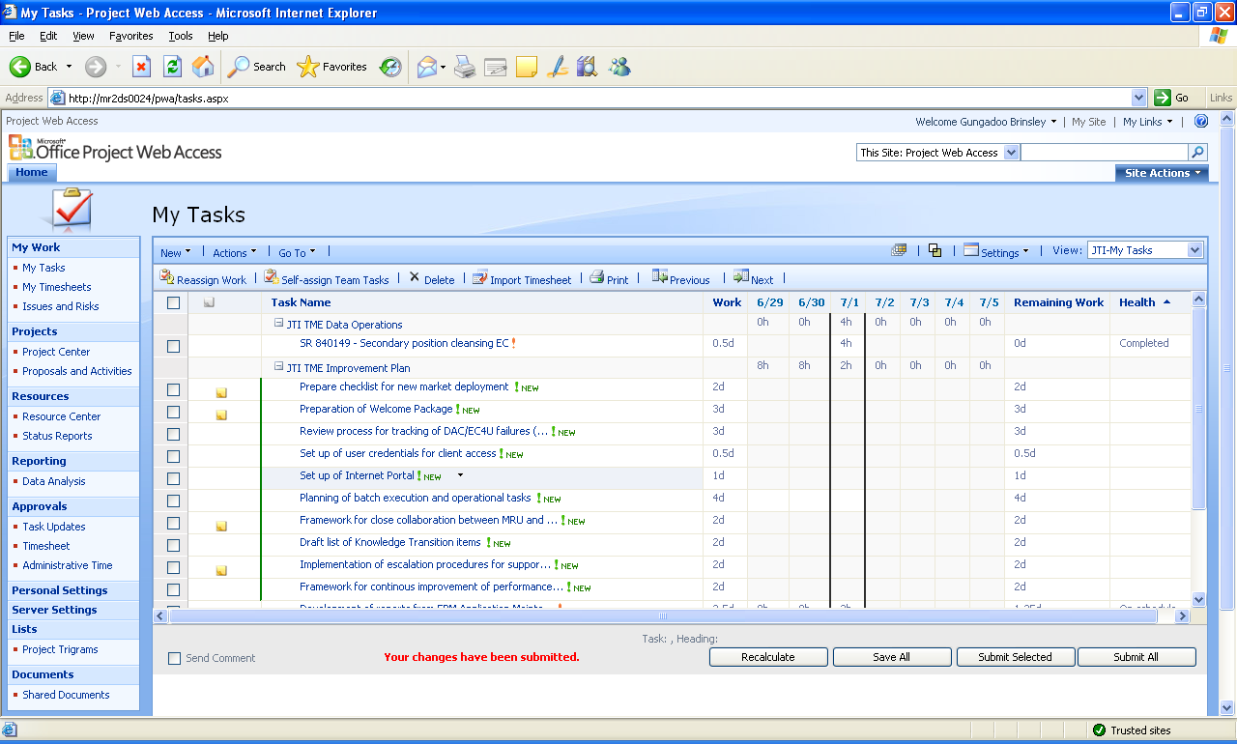

- After the timesheet entries have been imported and saved, the entries modified will need to be submitted so that they can be updated in the project plan accordingly. For that purpose either
  - Select the tasks to be submitted and click on the “Submit Selected” button
  - Or click on the “Submit All” button

Publishing project plan

After the different tasks have been imported in the project, the new project would need to be published on EPM. The following steps need to be performed for the publication of the new project plan on EPM:-

- Open Microsoft Office Project 2007 application.

- Clear the local cache by selecting Tools – Local Project Cache – Clean up Cache.

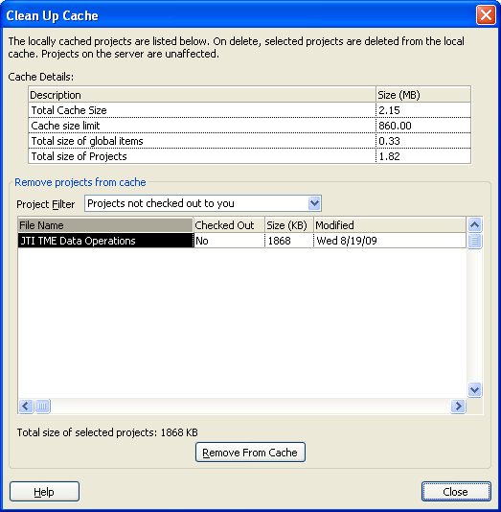

- Set the project filter to “Projects not checked out to you” and select the individual project entries and click on the “Remove from Cache” button.

- Once all cache entries are cleared, close the screen.

- Open the project from the EPM by selecting File – Open.

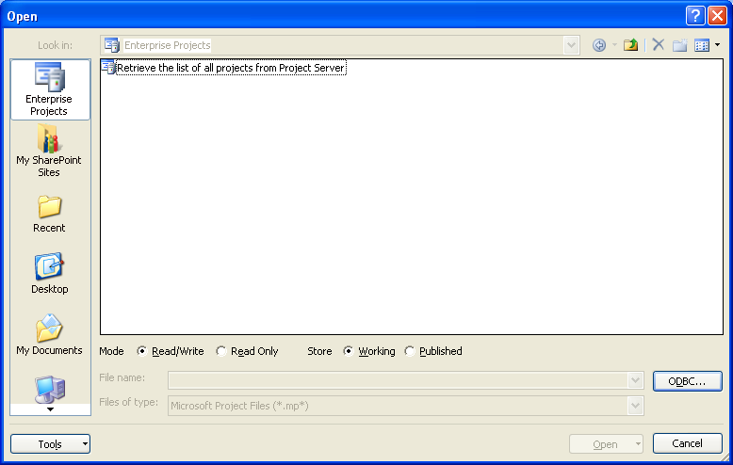

- Click on

- The list of available projects will be displayed as follows.

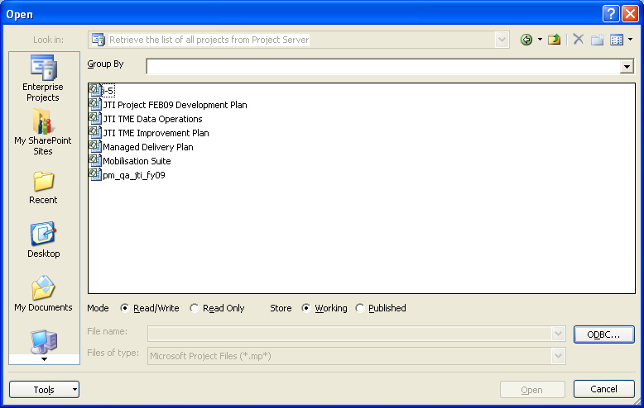

- Click on the required project to open it online.

- Make any modification as required to the project plan. Once ready, publish back the plan to the server.

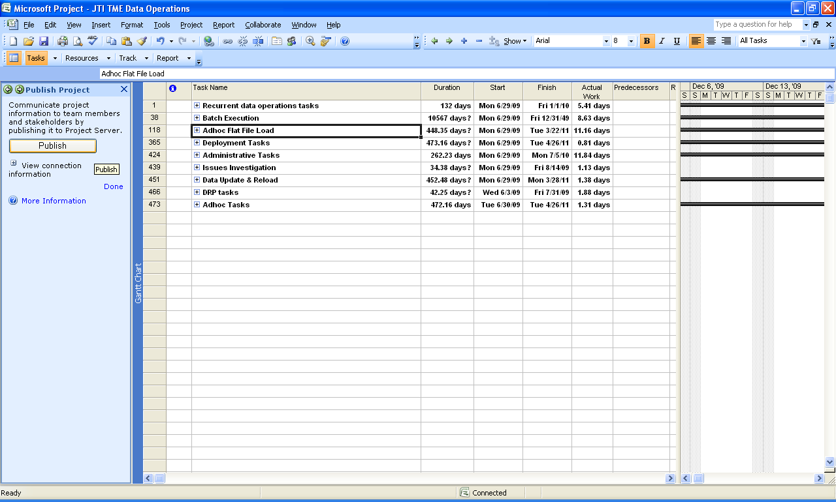

- Click on the button.

- A dialog box will be displayed prompting for saving the project plan before publication. Click on the Yes button.

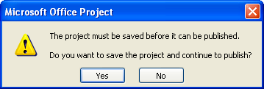

- The following will be displayed at the bottom

- When complete, the following message will be displayed

- You can then close the project plan accordingly.

Publishing project plan through web interface

The same operation is also possible through the web interface through the following steps:-

- Access Project Centre.

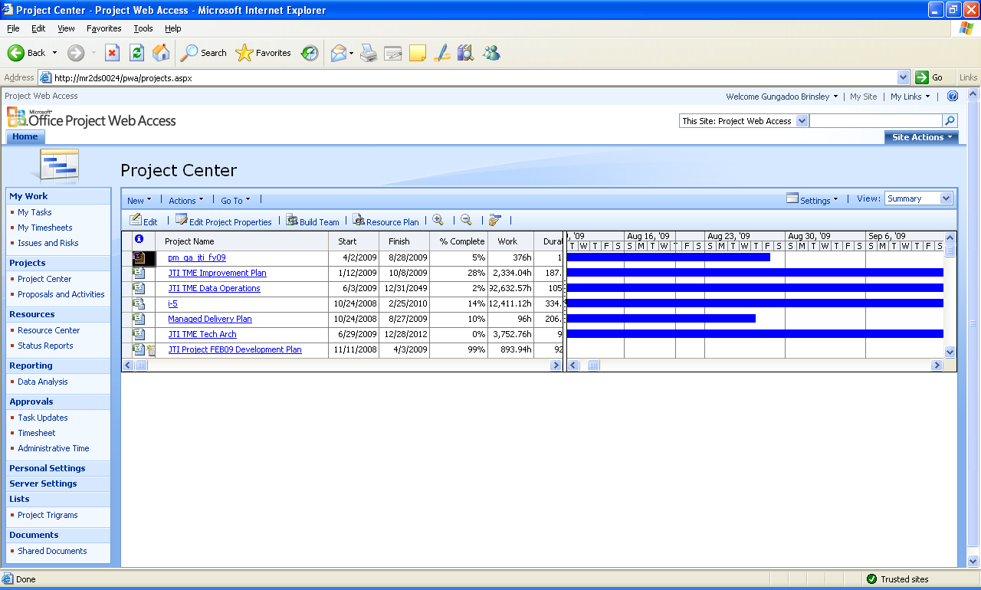

- Click on the project to be published.

- Click on.

- The following message will be displayed.

- Click on.

- The following will be displayed.

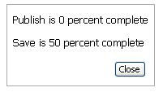

- Then click on the close button.

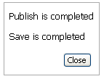

- Then click on the Cancel button.

- If requested to check in the project, confirm by clicking on the Yes button.

EPM Maintenance Steps

- Approve all Administrative Time pending.

- Import all timesheet pending.

- Import all tasks update received.

- Open project plan with Microsoft Project 2007 after clearing the cache.

- Update the Publish flag for completed tasks.

- Check that all tasks for Batch Execution and Adhoc flat file load have their jti_entity and jti_market filled in accordingly.

- Review tasks in project plan in terms of the different tasks entered.

- Publish project plan on EPM.

- Make backup copy of project plan through local saved file.

EPM Maintenance Checks

- Check whether all timesheet has been submitted

- Check whether there are any tasks with no actual on EPM

Force Check In a Project

- In Project Center, click on Goto -> Check in my projects

- The following screen will be displayed showing all the projects currently checked out by you:

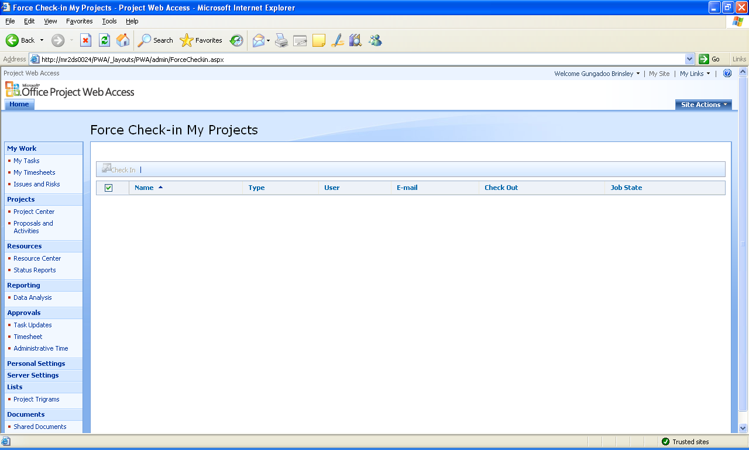

- Just click on the “Check In” button to forcefully check in that specific project.

